# Monty Bakery

Monty Bakery app allows the management of Products, shopping cart and users, typical for a supermarket. The app will most of the time be used by the store checkout clerks when customers bring in their items for billing.

There are 3 types of users of the app:

1. Super user- this user has access to all the functionality of the app and has the ability to configure users. Currently hardcoded to [admin@ad.com](mailto:admin@ad.com). A Super user will typically be the IT administrator of the store.
2. Admin user- this user has access to all the functionality of the app minus the ability to configure users. An Admin user will typically be the manager(s) of the store.
3. Store checkout user – this user has only functionality to use Shopping cart.

Each product can have multiples prices registered against them in the system. This is to allow for multi-priced items in stock.

# Main screens

## Login screen

In order to use the app, the user MUST login:

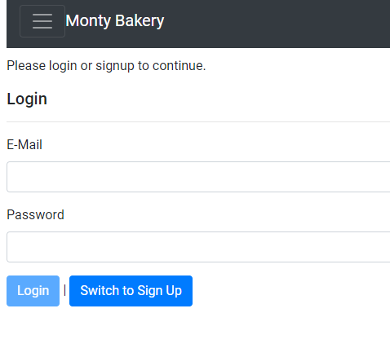

A new user can also sign-in by using the “Switch to Sign Up” button:

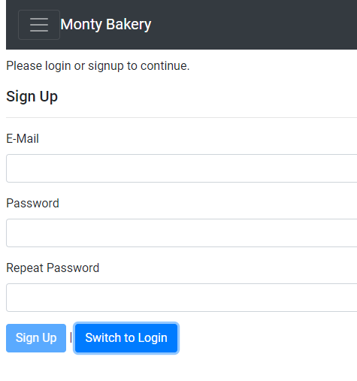

When a user signs up, they will by default get the Store checkout user access. If Admin access is required for the user, the IT administrator must grant them this access via the Configured Users screen below (see section 7).

## Options Menu

After logging in, the user can access the screens he/she has access to by clicking on the menu expander on the left. Then the menu options are displayed:

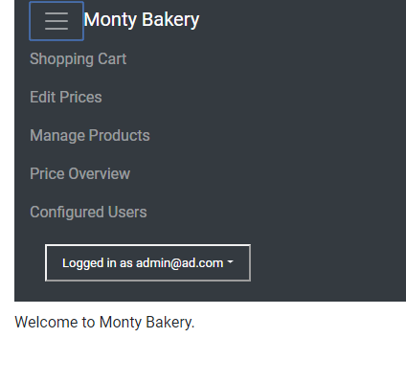

## Shopping Cart

Shopping cart is the page used by the Store checkout user. The user can populate the entire list of products or search for a specific product by Name or Barcode ID.

Click on a product of the Product List to add it to the cart:

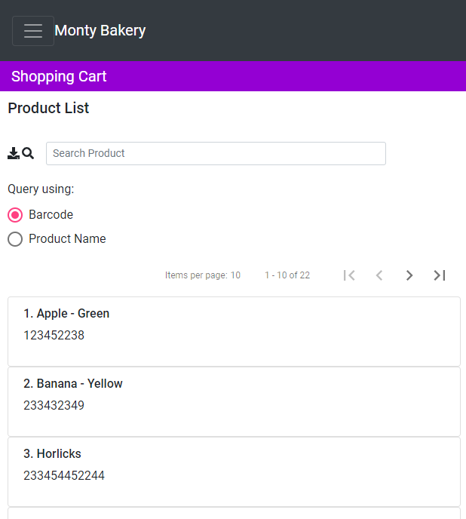

Then you will get a dialog where you can specify quantity to add, discount if applicable, and also select from one of the many registered prices in the system:

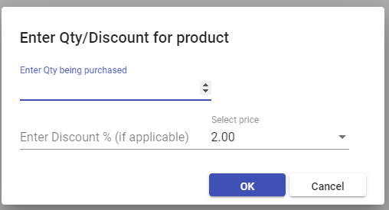

When pressing OK, the product is added to the cart displayed on the right:

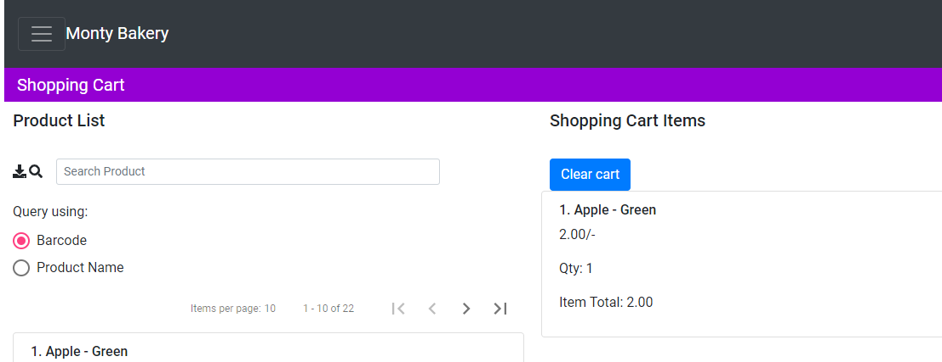

## Edit Prices

This screen is used by Admin Users to add/remove/modify ***prices*** registered in the system. Multiple prices can be registered against a product. Simply click on a product to edit the prices of ***existing products***:

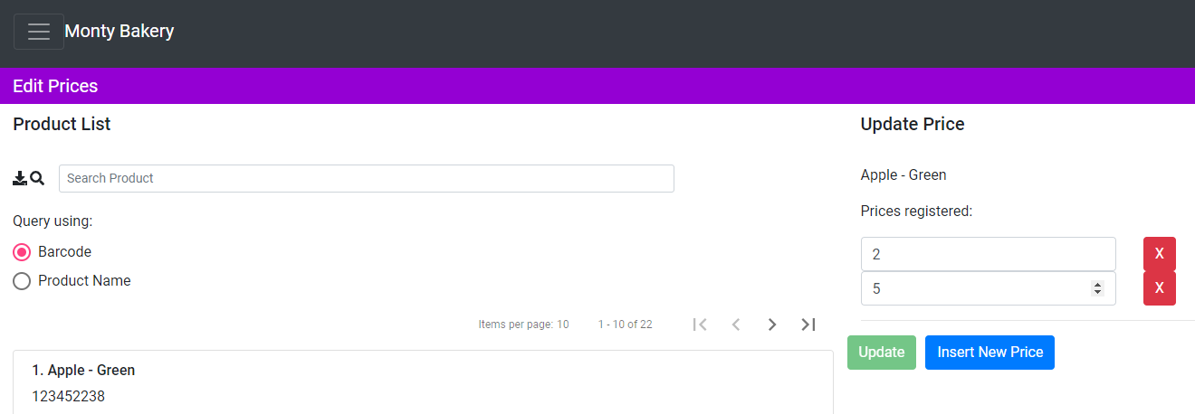

## Manage Products

This to add/remove/modify ***products*** registered in the system and is only accessible to Admin Users:

Adding a product:

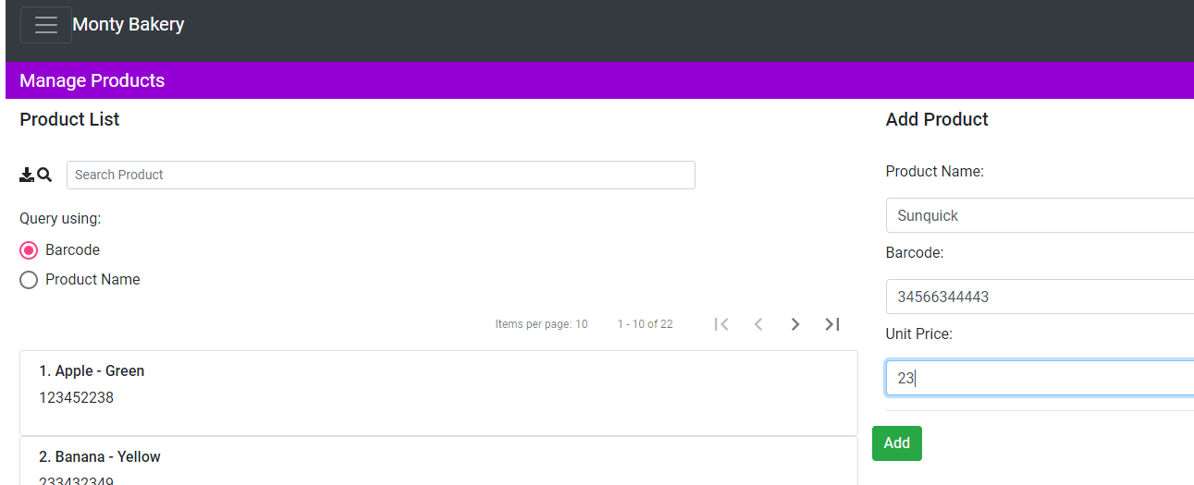

Modifying existing product or deleting (click on a product to do this):

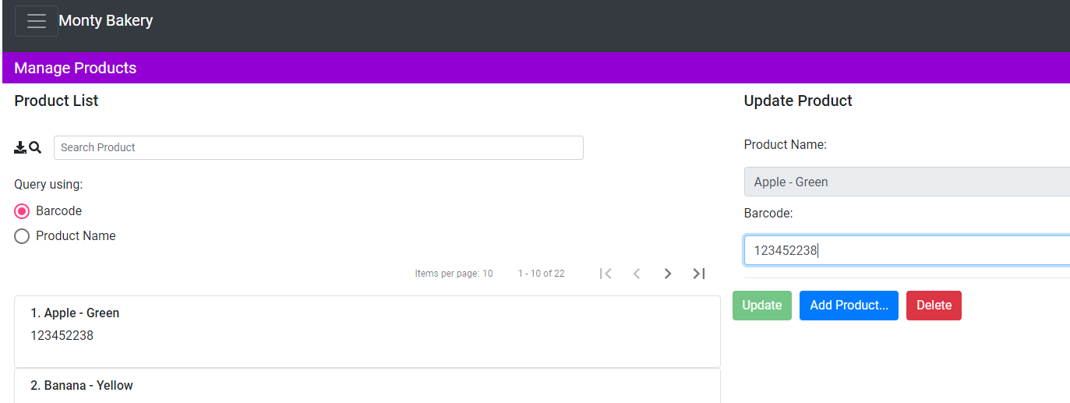

Note: you cannot adjust the prices of the product in this screen. Use Edit Prices screen to do this.

## Price Overview

This screen is used by Admins and is useful to spot products which have multiple prices registered in the system. This is useful when updating prices in the system. Prices can be easily edited by pressing “Edit” button:

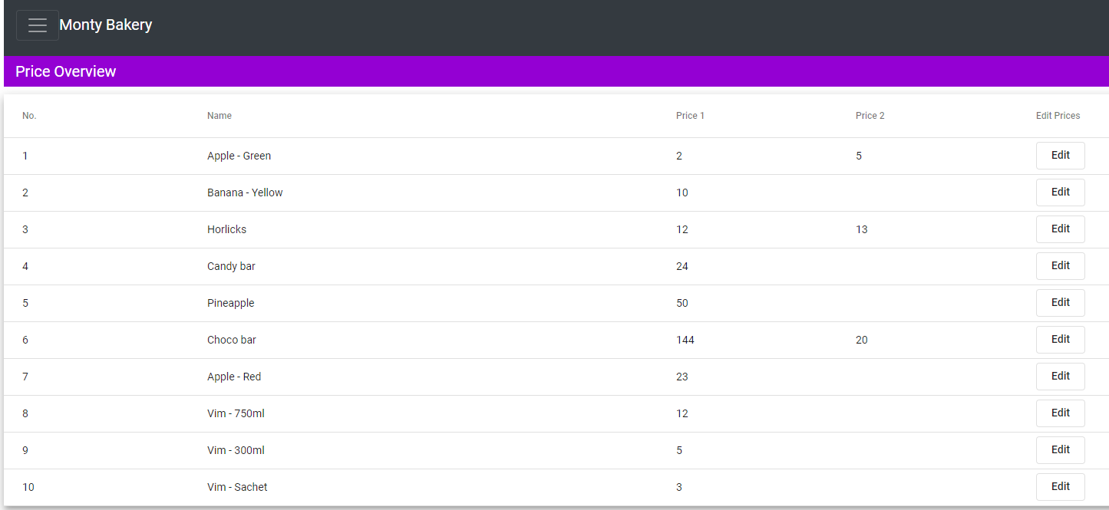

## Configured users

This screen is used by Super User to assign Admin privileges to users who have already signed up via the system. Users can be deleted as well.

